Lab Assignment 5

MQTT in IOT Applications

Part 1: Introduction to MQTT

MQTT (Message Queuing Telemetry Transport) is a lightweight and simple messaging protocol designed for use in machine-to-machine and Internet of Things contexts. It was developed in the late 1990s by Dr. Andy Stanford-Clark of IBM and Arlen Nipper of Arcom (now Cirrus Link Solutions). It was later standardized by OASIS (Organization for the Advancement of Structured Information Standards).

MQTT is based on a publish-subscribe model, in which clients can publish messages to a topic or subscribe to topics to receive messages. The broker, a central messaging server, routes the messages from publishers to the subscribers based on the topic hierarchy. Hence in MQTT, there is no direct communication between the clients. The protocol is built on top of TCP/IP and has a small packet size, which makes it efficient for use in low-power and low-bandwidth environments. It uses a three-level Quality of Service (QoS) system that allows publishers and subscribers to negotiate the level of reliability required for message delivery. Figure 1 gives a general idea of how the clients (publishers and subscribers) and the broker are structured under MQTT. Please refer to the Lecture notes for more details on how MQTT works.

[Fig. Source: A. Al-Fuqaha, “Internet of Things: A Survey on Enabling Technologies, Protocols, and Applications”, 2015.]

Figure 1: An example diagram of how MQTT works

This broker-clients structure place all the heavy work onto the broker so the clients can end up being lightweight. MQTT is widely used in many IoT applications.

Questions
- Why is MQTT built upon TCP? Why not UDP?
- What are some advantages and drawbacks of using MQTT in IoT? List at least 2 for each.
- What are some suitable IoT scenarios for applying MQTT? List at least 2.

In this lab, we will try to set up a simple IoT application using MQTT. Hopefully you will get a sense of why MQTT is popular in IoT applications.

Part 2: IOT Application

Scenario: Smart Check-In System using MFRC Reader

In this scenario, we will have a MFRC Reader connected to RPi. This will serve as the sensor when people check in using a tag. The RPi collects the reading from the tag and publishes the ID of the RPi, the name read from the tag, and current timestamp to some arbitrary topic, Timestamp for say. For example, if the RPi ID is 1, name is “Alapocas”, and timestamp is “2023-03-22 03:46:47”, the message your RPi publishes should be “1#Alapocas#2023-03-22 03:46:47”. The RPi also subscribes to a topic, UID for say, that will provide a UID which it should print out after a person gets an authenticated check in.

The PC should be subscribing to topic Timestamp to log the data. Upon receiving the message, the PC authenticates the Check-In by publishing a UID to topic UID. For example, if the RPi ID is 1, name is “Alapocas”, and UID is “8eb5689ce6f04d96b4f1971860a3d2a0”, the message your PC publishes should be “1#Alapocas# 8eb5689ce6f04d96b4f1971860a3d2a0”.

Finally, for the purpose of visualization, a simple Web UI is developed using node-red. This UI subscribes to both topics. Any new Check-In should be automatically updated onto the Web UI.

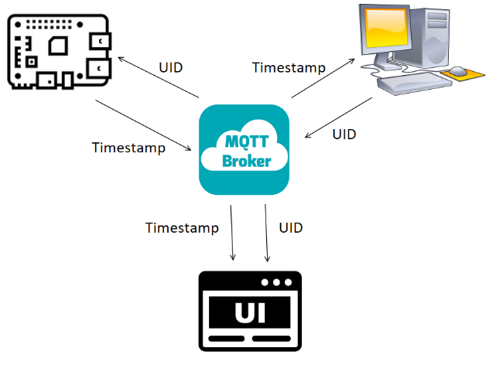
Figure 2: Diagram of how MQTT should work for this scenario

Implementation and Execution (both ECSE 4660 and ECSE 6660 students):

RPi:
- Wire up MFRC Reader on your RPi (see Lab 1 if you need to refresh your memory)
- Download “MFRC522_IOT.py”, “Lab5_PI.py” to your RPi.
- Execute “python Lab5_PI.py” in cmd window at directory where you stored “MFRC522_IOT.py” and “Lab5_PI.py”.
- You need to change the topic name in “Lab5_PI.py”, see Note 5 for why you want to change your topic name.

PC:
- Download “Lab5_PC.py” to your PC.
- Execute “python Lab5_PC.py” in cmd window at directory where you stored it.
- Since you changed the topic name in “Lab5_PI.py”, make sure to apply the changes accordingly to “Lab5_PC.py” as well.

UI:
- Type “node-red” in cmd window terminal to execute node-red locally.
- You should see some message like “Server now running at http://127.0.0.1:1880/” in the terminal. Copy the address and open in a browser. You should see something like the figure below:

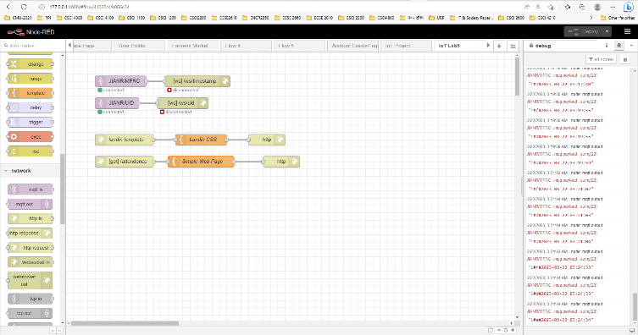
Figure 3: node-red terminal

- Download “flows.js” to your PC. Then click the upper right menu to find “Import” to import the flow.js to node-red:
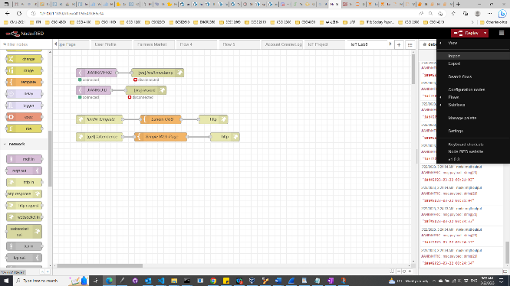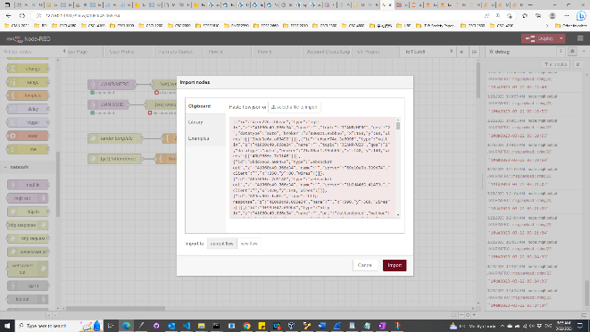
Figure 4: Import flow.json to node-red

- Modify the topic names to the ones you assign in Lab5_PI.py and Lab5_PC.py:

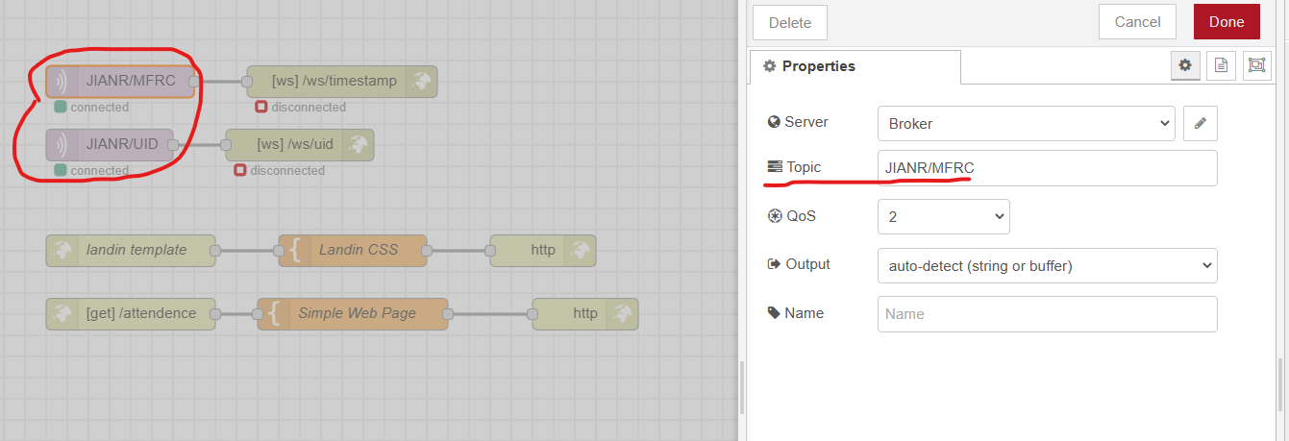
Figure 5: Modify topic name accordingly

- Click the Deploy button on the upper right. Then open up a new tab with address “http://127.0.0.1:1880/attendence” and you should see this:

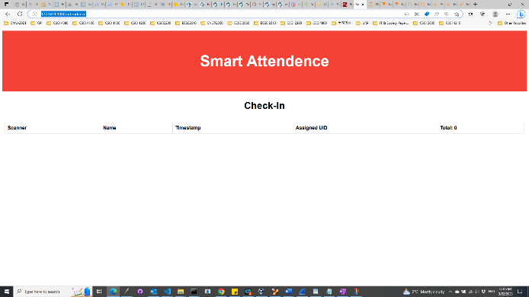
Figure 6: Web UI of the Check-In application

Notes:

- All code and node-red resources are hosted on https://drive.google.com/drive/folders/1k8hTuSxUa6AUGqiFvEIxIX7TzIcTUbgH?usp=sharing.
- If you see “ModuleNotFoundError: No module named 'paho'”, you need to install the module using “pip install paho-mqtt” or “pip3 install paho-mqtt”.
- Some other modules you may need to install are pytz, datetime, and uuid. They could be easily installed using pip.
- If you do not have node red installed, see installation guide here: https://nodered.org/docs/getting-started/local.
- Make your topic name unique/non-trivial. Since we will be using a public test broker (hosted at test.mosquitto.org) trivial topic name may be in use by others.
- For more information on paho-mqtt, please refer to the website here: https://www.eclipse.org/paho/index.php?page=clients/python/docs/index.php

Questions (for both ECSE 4660 and ECSE 6660 students):
- Provide screenshots of the code portion you modified. One for Lab5_PI.py and another for Lab5_PC.py.
- Provide screenshots of the RPi terminal and the PC terminal of successfully checking multiple people.
- Provide screenshot of the Web UI successfully logging multiple people.
- Use Wireshark on the PC to capture an MQTT PUBLISH packet during the communication. Take screenshots of the packet with MQTT details expanded and fill in the following table:

MQTT Section | Bit Range (start from 0) | Which fields are in the section and what are their values? (provide screenshots as evidence)
Fixed Header
Variable Header
Payload
Table 1: Packet analysis of a MQTT PUBLISH packet using Wireshark

- What is the function of each field in each section?
- From your capture, what is the IP address and port number of your broker?
- Suppose your Raspberry Pi or PC is unable to connect to the broker. Across the network, transport, and application layers, what key diagnostic steps would you take to identify the issue? Be as specific as possible, including the exact commands you would use.
- If you do not want your broker to be hosted on the internet, what changes would you make to its IP address to ensure the MQTT service continues to function correctly? Provide an example of a suitable IP address based on your current network configuration.

Deliverables
- Answer all the questions in Part 1 ( both ECSE 4660 and ECSE 6660 students).
- Answer all the questions in Part 2. (both ECSE 4660 and ECSE 6660 students).

References
- Figure 1: Image from the Internet: https://pimages.toolbox.com/wp-content/uploads/2022/06/11060901/MQTT-Process.png
- NodeRed official website: https://nodered.org/docs/getting-started
- Paho-mqtt official website: https://www.eclipse.org/paho/index.php?page=clients/python/docs/index.php

If you have any questions, please turn to, ask on Piazza, or email the Lab TA:

· Chibuikem Ezemaduka (ezemac@rpi.edu)

